***Calculus II Notes Summer 2012***

Looking back: Initial Take-home quiz

Fear of Physics.com

Looking forward: Maxwell’s Equations

How many dimensions are there? (Some class discussion)

What is a vector? (Some class discussion)



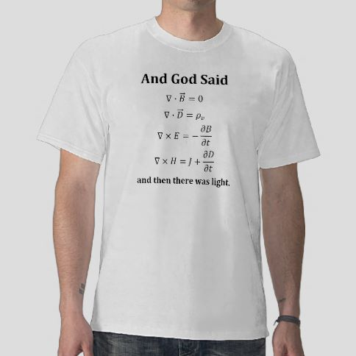

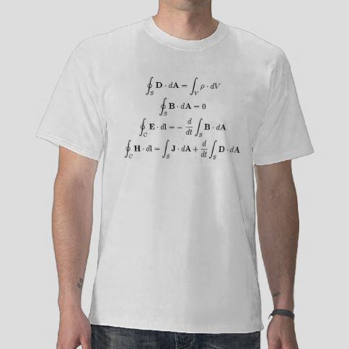

We will study vectors, here and now, in two and three dimensions. We will start with 2 dimensions; make a jump to three dimensions. Although there are some differences between two and three dimensions, there is also great similarity – so we will treat the two dimensional case carefully, and the three dimensional cases with greater dispatch. The steps to higher dimensions are pretty straight forward. We will be doing fundamental vector arithmetic and geometric operations in Calculus II. The calculus of vectors will be discussed in Calculus III at COD.

Some definitions and notations from the book are useful (***Go to page 764***):

* Scalar (You are going too fast, go five miles…)
* Directed line segment
* Initial point
* Terminal Point
* Notations (Popeye, I am what I am…)
* Arrow representation of vectors (equivalence classes, ¾ = 6/8….) (standard position..)
* Magnitude or norm notation
* Distance formula in two or three dimensions
  + Equation of a circle
  + Equation of a sphere
  + Midpoints of segments

***Example 11.1.1 – Problem 4***

So vectors are mathematical objects, sort of like, arrows. We will soon establish operations on these mathematical objects just like we do operations on numbers or on functions. But first some definitions.

Definition of the component form of a vector (***Page 765***)

Other useful definitions:

* Standard position
* Equality of vectors
* Length of a vector
* Unit vectors

***Example 11.1.2 – Problem 8***

***Example 11.1.3 – Problem 10***

Mini theorem – the only vector with zero length is the zero vector

We need to define some operations: *Page 766*

* Sum
* Difference
* Scalar multiplication

***Example 11.1.4 – Problem 24***

Resultant vectors

Geometric interpretation with arrows

These operations have a number of core properties, just like numbers do.

Theorem on properties of vector operations on ***page 767***

Any set of vectors, with an associated set of scalars, and an associated suite of operations forms what is called a vector space. This is an important mathematical object and is studied extensively in courses called Linear Algebra. At COD, the Linear Algebra course is studied as Math 2245. It has many applications to differential equations and to Video Game programming among other things (Page 768)

Theorem on the length of a scalar multiple (***Page 768***)

Theorem showing how to find a unit vector in a given direction ***(Page 768)***

This is an operation I will ask you to do and is called normalization. (This is kind of like normalizing exam scores).

***Example 11.1.5 – Problem 36, 38***

***Page 769***

Generally the norm of the sum of two vectors is NOT equal to the sum of the norms. This is known as the triangle inequality for vectors. It is only equal if the vectors are in the same direction.

Another representation that is extremely useful is called the standard unit vector representation. This essentially means that every vector in the entire vector space may be represented by a linear combination of these vectors. Such a set of vectors is called a basis. We will speak in two dimensions of these comprising the horizontal and vertical components. In three dimensions we will speak of the x, y, and z components.

***Page 770***

A final very important representation is in terms of the unit vectors on the unit circle.

This enables us to write, in a different way, a vector with a given magnitude and direction.

Applications

Bearing and Forces….

***Example 11.1.6 Problem 90***

***Example 11.1.7 Problem 94***

Now for three dimensions terminology

* Octants
* Planes
* Right hand system
* Standard vector notation
* Distance formula in three dimensions
* Equation of a sphere via completing the square
* Definition of parallel vectors
* Vectors in space conventions..

***Example 11.2.1 – Problem 8, 22***

***Example 11.2.2 – Problem 32***

***Example 11.2.3 – Problem 40, 44***

***Example 11.2.4 – Problem 74***

***Example 11.2.5 – Problem 87***

***Example 11.2.6 – Problem 96***

***Example 11.2.7 – Problem 112, 114***

***Chapter 11.3 – The Dot (or inner) Product***

Definition of dot product of two vectors Page 783. In contrast to the other vector operations studied, the result of the dot product yields a scalar, not a vector.

Properties of the dot product

Theorem on the angle between two vectors in standard form.

Alternative form of the dot product

Definition of orthogonal vectors and subsequent note

Concept of direction cosines and calculations

Decomposition of a vector into components, perpendicular and parallel to a given vector.

Projections using dot product theorem

Physical applications thereof

Example 11.3.1 : #8

Example 11.3.2: # 10

Example 11.3.3: # 18

Example 11.3.4: # 26

Example 11.3.5: # 32

Example 11.3.6: # 42

Example 11.3.7: # 48

Chapter 11.4 The Cross product…

Definition of the cross product of two vectors in space

Theorem on the properties of vector cross products

Theorem on the geometric properties of cross products

Applications of torque

Triple scalar product definition and application

Example 11.4.1: 1 – 6, # 10

Example 11.4.2: #16

Example 11.4.3: # 22

Example 11.4.4: # 34

Example 11.4.5: # 39, #40

Example 11.4.6: # 46